**Database Project part3**

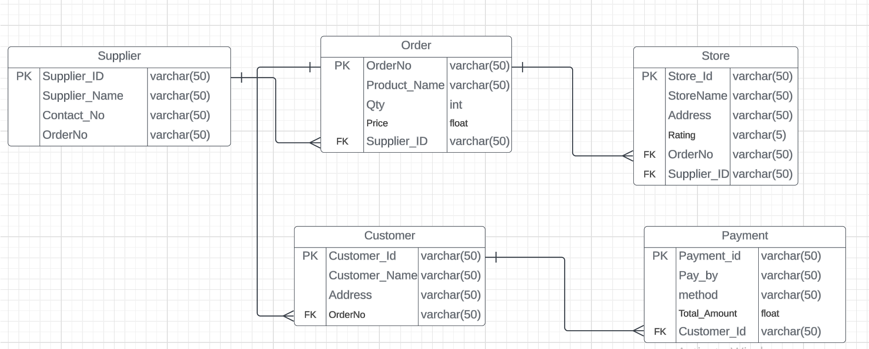

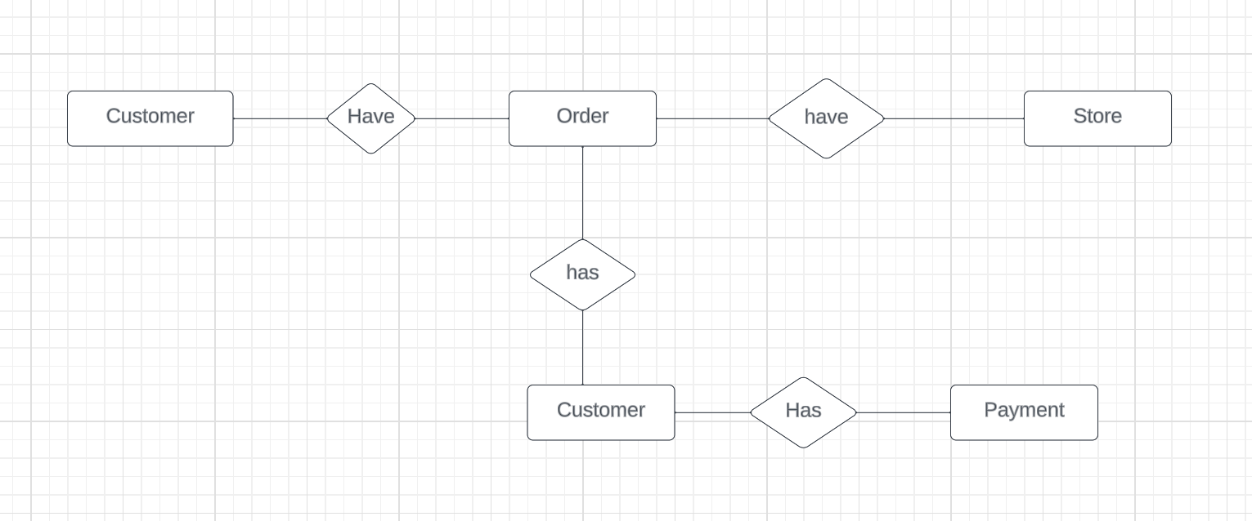

Supplier table are depend on Order table in a one to many relationship

Order table depend on Store table in one to many relationship

Order table are also depend on Customer table in one to many relationship

Customer table is dependent on the Payment table.